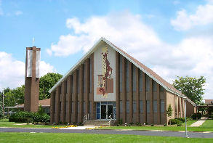
St. Francis Xavier Church
25 West Perry Street Willard, OH 44890 419.935.1149
Baptism Registration Form
Child |  | Click here to enter today’s date.
Full Name |  | Click here to enter text. Choose an item.
Birth: Date & Place: |  | Click here to enter text. at enter city and state.
Previously Baptized? |  | Choose an item.
Mother
Full (Maiden) Name |  | enter text.
Marital status |  | Choose an item.
Religion |  | Choose an item. Choose an item.
Address |  | enter text.
Phone & Email |  | enter text.
Father
Full Name |  | enter text.
Marital status |  | Choose an item.
Religion |  | Choose an item. Choose an item.
Address |  | enter text.
Phone & Email |  | enter text.
Godparent(s) [Must be Catholic. Need letter from their parish stating they are practicing and in good standing.]
Godfather |  | enter text.
practicing? |  | Choose an item. Enter name of church, city, state.
Godmother |  | enter text.
practicing? |  | Choose an item. Enter name of church, city, state.
Christian Witness [optional if only one godparent and must be opposite gender, but they need to initiate the request]
Name and religious denomination |  | enter text.
Other Parent Information
Parish of Parent Registration |  | enter name and place.
 |  | enter address.
 |  | enter phone number.
Marital Validity |  | Choose an item.
Last attendance of Baptism Prep Program |  | Enter year and place.
Request for particular priest/deacon |  | enter name (and contact info if not from our parish).
Requested date & time |  | enter date and time – 1:30pm Sunday is the norm.
Other comments:
Click here to enter additional notes.

Baptism performed by __________________________________ on the following date:_____________.

